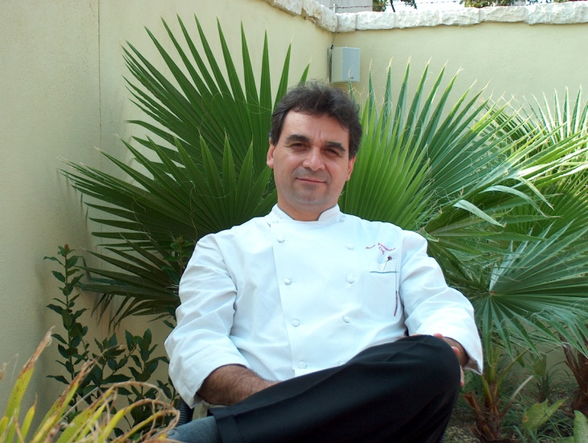

Chef Rene Fernandez discovered he had an exceptional passion for food and the culinary arts as early on as eight years old, when he remembers becoming enamored with the “beautiful and abundant” paella he first sampled in a Spanish restaurant in Mexico City. He studied at the Culinary Institute of America, as well as took specialty courses in food and beverage at Cornell University. He is also a proud member of Chaine Des Rotisseurs.

Although born and raised in Mexico, Chef Fernandez began his career working as a cook at a country club in Houston, TX. He quickly and seamlessly moved his way up the ladder from Chef Garde Manger at the Sheraton in Mexico City to the Tropicana Hotel in Manaus, Brazil to Sous Chef at the Hyatt Hotel in Acapulco, a 700-room resort. Eventually he moved on to the Westin Comino Real Guatemala where he finally earned the esteemed title and responsibility of Executive Chef. From there he continued his career as an Executive Chef at various exotic locations around the world, from Cancun to Aruba and Puerto Rico, Collectively, Chef Fernandez has worked a total of 17 years at Hyatt Hotels alone.

In 1993, at the Hyatt Regency in Merida, known as the white city, in the Yucatan Peninsula in Mexico, Chef Rene met Pierre Kranzle, who went on to become his business partner. Their first venture, in 2002, was Azuca Nuevo Latino Restaurant & Bar, which has become a highly successful local and tourist favorite in the Southtown arts district in San Antonio. The two also successfully opened and sold another Latin-themed restaurant called Pasion, as well as developed the World Cuisine Catering Company, which continues to grow and expand.

Now, after a decade of successful ventures, Kranzle has gone on to pursue his own interests while Chef Rene has continued to pursue his own culinary inspirations. Recently, Chef Rene has been inspired to join the Slow Food Movement, a movement towards using fresh, local ingredients and well-maintained livestock (including no hormones or chemicals), in order to create a sustainable ecosystem. He has also joined the growing ranks of vegans, so as to encourage a healthy lifestyle for his children and grandchildren. This new lifestyle change has resulted, in a short amount of time, in shedding extra pounds, more energy and more and more inspiration every day.

The importance of children’s nutrition has become a growing passion of his. “I feel a responsibility now to be, not only using good wholesome ingredients in my own dishes, but to teach others. Illness in America has become a serious problem, and I believe it’s largely due to fast and processed foods. Our approach needs to shift towards teaching kids how to eat and be healthy. That means eliminating things like processed sugars and grains,” says Chef Rene. “The good news is it’s easy and fun! Cooking with and for my family is one of my greatest pleasures!” Chef Rene has spent numerous hours investigating what needs to be done to provide children with more nutritious yet still quite tasty dishes. With that in mind, He is now the Chef in charge of the nutrition program at St. Anthony Middle School, cooking daily for over 400 students and making the difference on the “typical cafeteria food” this visionary entrepreneur is on the verge of opening a new restaurant with his son, Diego, called Starfish, which will be located next to Azuca. Starfish will offer global cuisine with a focus on foods from the sea and in sharing dishes that feature as well local fruits and vegetables, free-range chicken and naturally-grown beef and pork. Chef Rene is leading the way down a new, much needed path to healthy yet still delicious food!

